Initial Ideas

The motor will need to be on for a set period of time and off for a set period of time corresponding to the configuration of the first four switches. If a motor on delay of 50000h and a motor off delay corresponds to maximum motor speed. To work at increments of that speed (in 16ths), the following equation should be adopted:

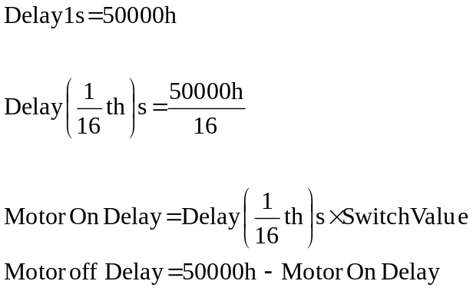

Program Outline

Set up the input and output lines on the 68320

Read Switches

- If the Switch value is equal to zero then quit, else run the motor forwards

- Dependent on the switch value run the motor forwards for a specified time

- Dependent on the switch value turn the motor off for a specified time

- Repeat

Program Code

.define pitbase = 0ffff81h
.define pgcr = 0
.define psrr = 2
.define paddr = 4
.define pacr = 0ch
.define paar = 14h
.define padr = 10h; used to read data from portA
;
.define submodelx = 80h
.define out76 = 0coh; lines 7&6 outputs, rest inputs
;
.define forwards = 80h
.define stopit = 0
.define delay1s = 1000h
.define sixteen = 10h
;
.psect _data
switchvalues: .byte 0
;
.psect _text

mainprog: bsr.s setup ; setup interface
bsr.s readswitches ; read switches 0 to 3
bsr.s motorforwards ; motor operates in forward direction
bsr.s timedelay ; for a specified time
bra.s mainprog ; repeat main program again
;
setup: movea.l #pitbase, a0 ; the memory location for the pitbase
; is pointed at by address register
; a0
;
move.b #submode1x, pacr(a0) ; work in operating mode
; submode1x
;
move.b #0, padr(a0) ;initialise padr
move.b #out76, paddr(a0) ; lines 7&6 are outputs
; the rest are inputs
rts
;
readswitches: move.b paar(a0), d0 ; move portA switches data
; to D0
move.b d0, (a1) ; a1 points to the storage
; for the switch settings
;
bclr #4, d0 ; clear bit 4 of D0
bclr #5, d0 ; clear bit 5 of D0
bclr #6, d0 ; clear bit 6 of D0
bclr #7, d0 ; clear bit 7 of D0
move.b d0, switchvalues ; move the switch values to
; a memory location called
; switchvalues
cmpq d0, #0 ; If the values on switches
beq stopdead ; 0 – 3 are zero, stop motor
rts
;
Stopdead: move.b #stopit, padr (a0) ; Calling this subroutine
Trap #4 ; will stop the operation
; of the motor
;
Motorforwards: move.b #forwards, padr (a0) ; Instruct the motor to run
; forwards
rts
;
Timedelay: move.l #delay1s, d1 ; D1 is the element counter (preset
; to delay1s)
divu #sixteen, d1 ; Divide value stored in d1 by sixteen
mulu switchvalues,d1 ; Multiply value of switches
Timeon: compI #0 , d1 ; does d1 equal zero?
dbeq.s d1, Timeon ; if yes goto subroutine Timeon
rts
;
Stopmotor: move.b #stopit, padr(a0) ; stopping signal
Move.l #delay1s, d0 ; copy total time into d0
Sub.l d1, d0 ; subtract time on from total time
; giving the required motor off time
Timeoff: cmpI #0, d0 ; does d3 equal zero?
Dbeq d0, Timeoff ; if yes goto subroutine Timeoff
rts

